Vietnam's consumer price index (CPI) from 2000 to 2023

# General comment

General trend: Vietnam's CPI tends to increase in the period 2000-2023, with an average increase of 6.2%/year. However, the CPI growth rate has tended to decrease in recent years, from 16.8% in 2008 to 3.1% in 2023.

Impacting factors: Vietnam's CPI is influenced by many factors, including:

Internal factors: Prices of domestic goods and services, exchange rates, monetary and fiscal policies.

External factors: Prices of imported goods and services, prices of goods and services on the world market.

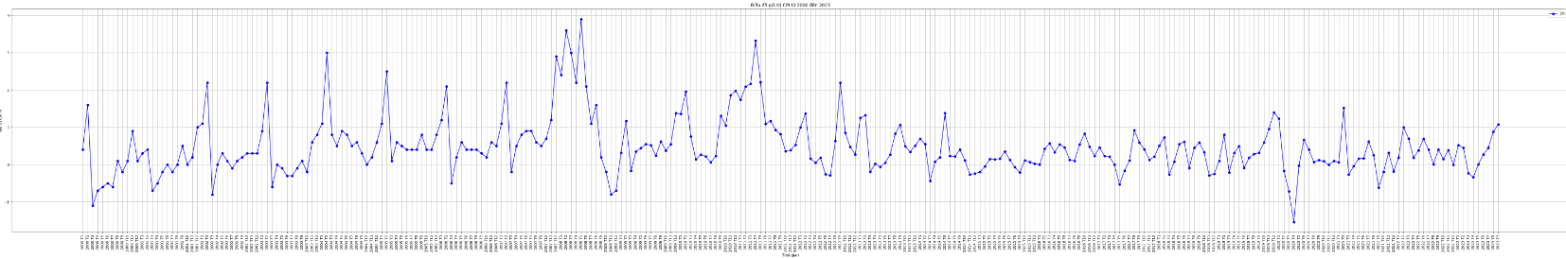

# Reviews by stage

Vietnam's consumer price index (CPI) from 2000 to 2023 can be divided into three main periods:

## Phase 1 (2000-2010):

During this period, Vietnam experienced several major economic upheavals, including the 2008 global financial crisis³. This has led to fluctuations in CPI. Vietnam's CPI index during this period increased sharply, with the inflation rate in 2010 being 9.19%².

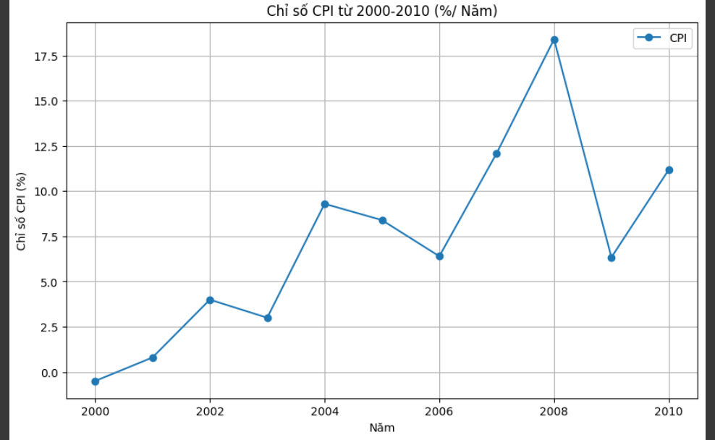

## Phase 2 (2011-2020):

This period saw more economic stability, with CPI rising steadily². However, 2011 had an inflation rate of 18.58%, the highest in this period². After that, the inflation rate gradually decreased and remained stable at about 4% in the period from 2016 to 2020².

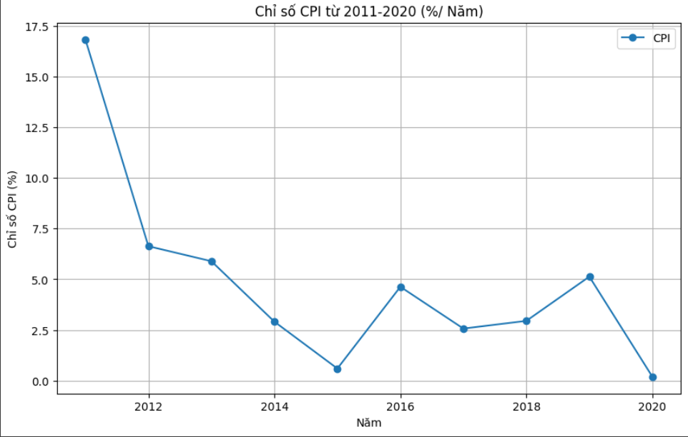

## Phase 3 (2021-2023):

During this period, CPI continued to increase⁷⁸⁹. According to data from the General Statistics Office of Vietnam, CPI in August 2023 increased by 2.02% compared to December 2022 and increased by 2.96% over the same period last year⁷. On average in the first 8 months of 2023, CPI increased by 3.1% over the same period last year⁷. Forecasts suggest that the average CPI in 2023 will increase between 3.2% and 3.6%⁹.

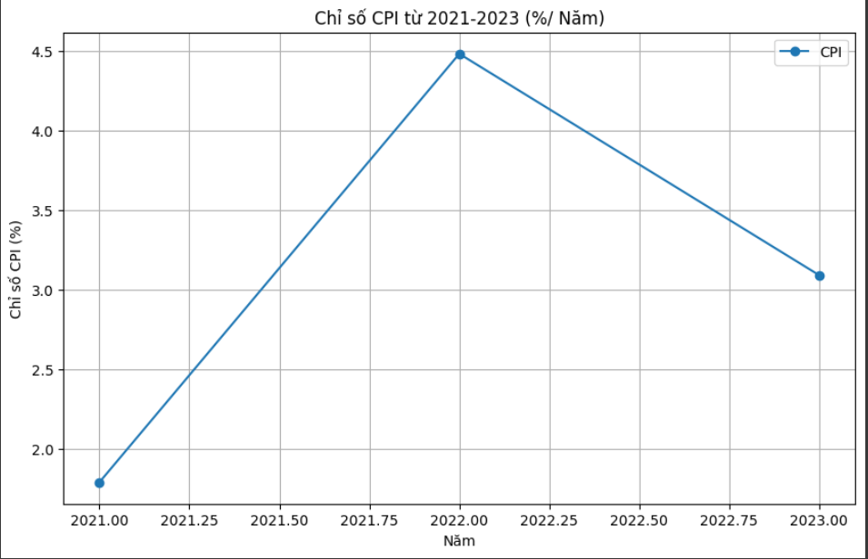

(1) Vietnam's socio-economic situation in the ten years 2001-2010. [https://www.gso.gov.vn/du-lieu-va-so-lieu-thong-ke/2020/10/tinh-hinh-lanh-te-xa-hoi-viet-nam-muoi-nam- 2001-2010/](https://www.gso.gov.vn/du-lieu-va-so-lieu-thong-ke/2020/10/tinh-hinh-kinh-te-xa-hoi-viet-nam-muoi-nam-2001-2010/)

(2) Vietnam Inflation Rate Over the Years in the Period 2010 - 2020. <https://lodongxu.com/ty-le-lam-phat-viet-nam-qua-cac-nam-2/>

(3) CPI - sbv.gov.vn. <https://www.sbv.gov.vn/webcenter/portal/vi/menu/rm/cpi>

(4) What is the current CPI in Vietnam 2023? - THE LIBRARY OF LAW. [https://thuvienphapluat.vn/lao-dong-tien-luong/cpi-la-gi-cpi-viet-nam-2023-la-bao-nhieu-va-co-anh-huong-toi-doi-song- cua-people-labor-dong-good-not-9870.html](https://thuvienphapluat.vn/lao-dong-tien-luong/cpi-la-gi-cpi-viet-nam-2023-la-bao-nhieu-va-co-anh-huong-toi-doi-song-cua-nguoi-lao-dong-hay-khong-9870.html)

(5) Vietnam's Consumer Price Index (CPI) (yearly). <https://vn.investing.com/economic-calendar/vietnamese-cpi-1851>

(6) CPI VI – General Statistics Office of Vietnam. <https://www.gso.gov.vn/cpi-vi/>

(7) Topic Analysis and evaluation of Vietnam's consumer price index in the period .... [https://luanvan.co/luan-van/de-tai-phan-tich-va-danh-gia-chi -so-price-of-use-of-viet-nam-giai-doan-2008-6-month-dau-nam-2010-23573/](https://luanvan.co/luan-van/de-tai-phan-tich-va-danh-gia-chi-so-gia-tieu-dung-cua-viet-nam-giai-doan-2008-6-thang-dau-nam-2010-23573/)

(8) Average GDP reaches 2,750 USD/person in the period 2016 - 2020. [https://vnbusiness.vn/viet-nam/gdp-binh-quan-dat-2-750-usd-nguoi-giai-doan-2016 -2020-1073525.html](https://vnbusiness.vn/viet-nam/gdp-binh-quan-dat-2-750-usd-nguoi-giai-doan-2016-2020-1073525.html)

(9) CPI - sbv.gov.vn. <https://www.sbv.gov.vn/webcenter/portal/m/menu/trangchu/cpi>